SR UNIVERSITY

**AI CODING**

**ASSIGNMENT NO : 3**

**NAME Bhavana.Pommedi**

**ENROLLMENT NO :2403a54069**

**BATCH NO :03**

**3.1:**

* **PROMPT: Ask AI to write a function to calculate compound interest, starting with only the function name. Then add a docstring, then input-output example**

**Expected Output#1**

* **Comparison of AI-generated code styles7**

**CODE:**

**OUTPUT:**

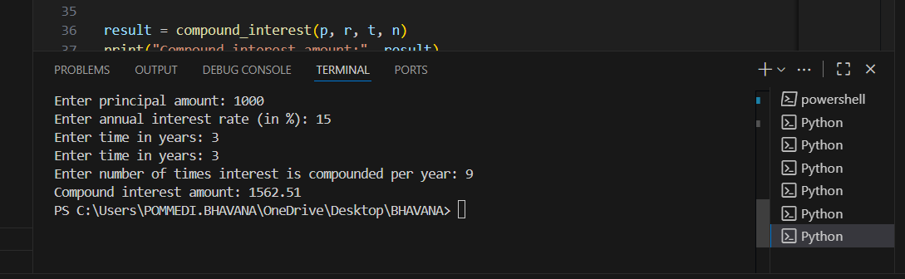

**EXPLANATION:**

**3.2:**

**PROMPT: Do math stuff, then refine it to: # Write a function to calculate average, median, and mode of a list of numbers.**

**Expected Output#2**

* **AI-generated function evolves from unclear to accurate multi-statistical operation.**

**CODE:**

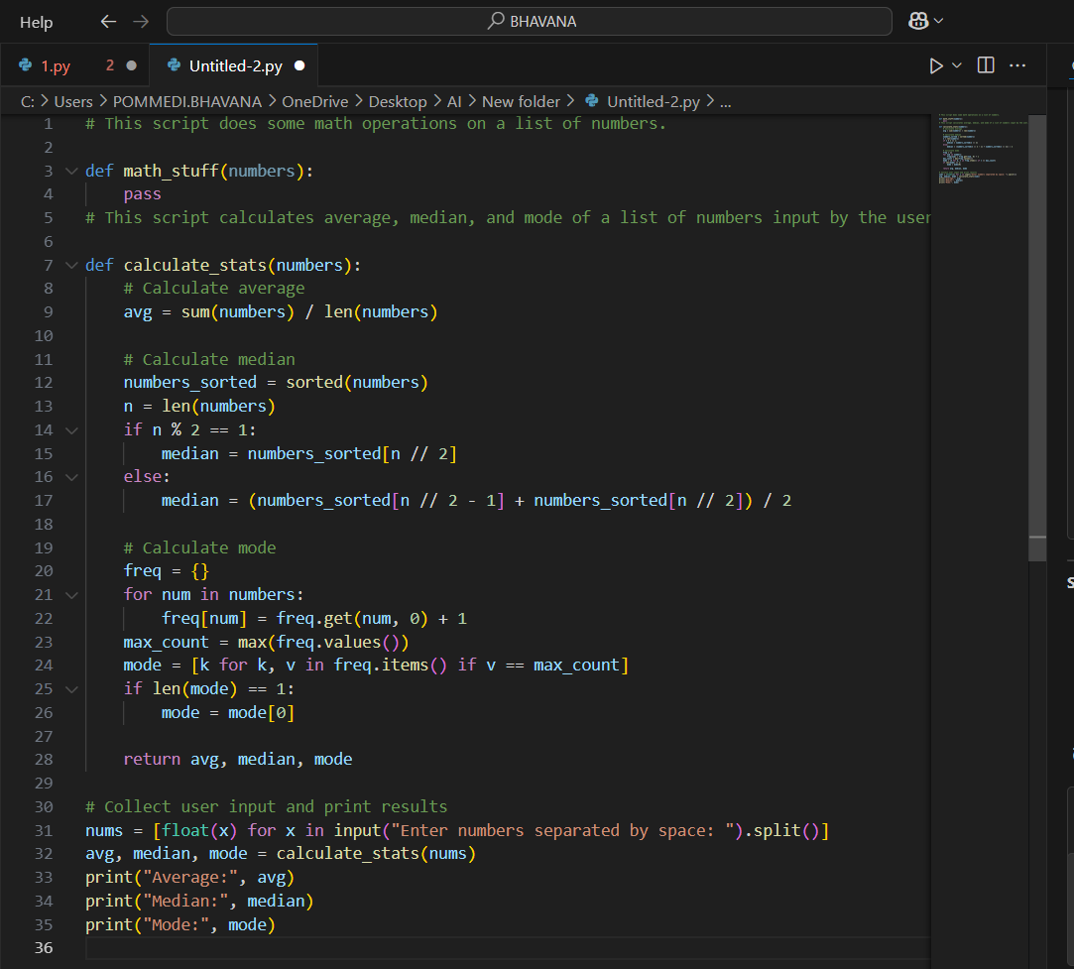

**OUTPUT:**

**EXPLANATION:**

**3.3:**

**PROMPT: Provide multiple examples of input-output to the AI for convert_to_binary(num) function. Observe how AI uses few-shot prompting to generalize.**

**Expected Output#3**

* **Enhanced AI output with clearer prompts**

**CODE:**

**OUTPUT:**

**EXPLANATION:**

**3.4:**

**PROMPT:Create an user interface for an hotel to generate bill based on customer requirements**

**Expected Output#4**

* **Consistent functions with shared logic**

**CODE:**

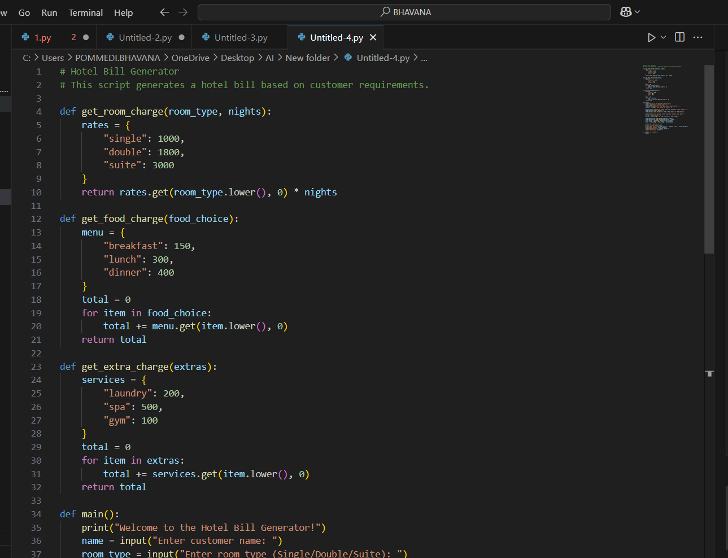

**OUTPUT:**

**EXPLANATION:**

**3.5:**

**PROMPT: Analyzing Prompt Specificity: Improving Temperature Conversion Function with Clear Instructions**

**Expected Output#5**

* **Code quality difference analysis for various prompts**

**CODE:**

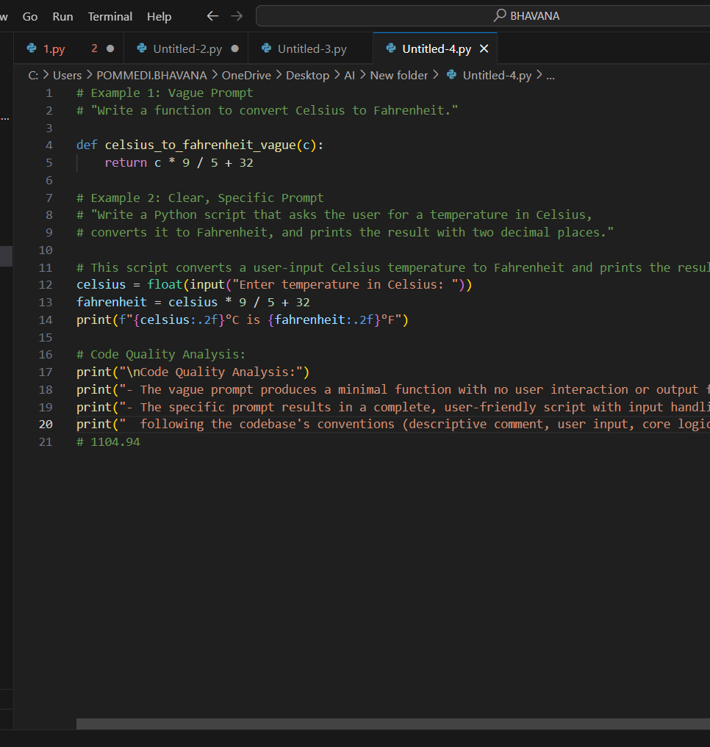

**OUTPUT:**

**EXPLANATION:**

